Caldera Warmstone heat battery offers ‘game changing’ low-carbon technology for homes
Emily Gosden, Energy Editor
Monday May 17 2021, 12.01am, The Times
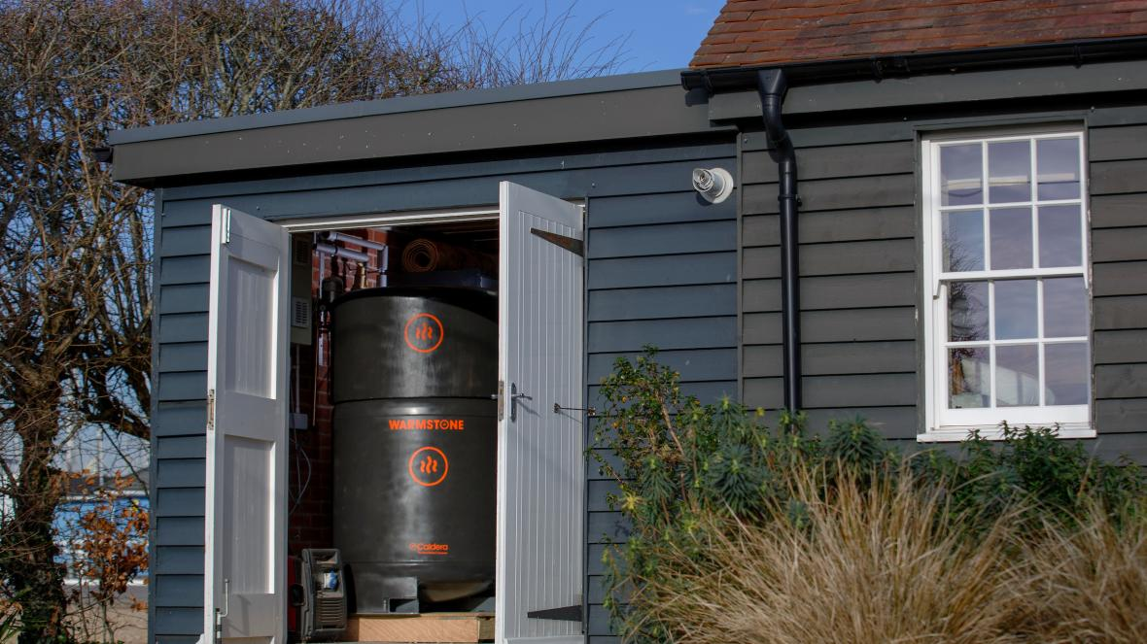
Caldera has so far secured about £1.2 million of funding from the government and official agencies for its heat battery
LUKE MACGREGOR
Share

Save

Homes could be kept warm with giant “heat batteries” developed by a British start-up that has won backing from the government and external investors.
Caldera, based in Hampshire, uses cheap off-peak power and electrical elements to heat a huge highly-insulated block of material called Warmstone, made from recycled metals and aggregate. A coil of water pipes pass through the block, heating up water that can then be used in a conventional central heating system with radiators and a hot water tank.
Weighing 1.7 tonnes and measuring 1.7 metres tall by 1 metre diameter, the heat battery is intended to be installed outside a property and to be used primarily as a replacement for oil or LPG boilers, which are used in more than a million of the homes that are not on the gas grid.

IN YOUR INBOX
Business Briefing
In-depth analysis and comment on the latest financial and economic news.
Sign up now
Oil heating systems are due to be phased out in coming years to meet climate targets but switching to electric-powered air-source or ground-source heat pumps is likely to prove challenging in older properties with solid walls and poor insulation.
Heat pumps can cost anywhere from £5,000 to more than £15,000 to install depending on type but insulation and other changes to make them work efficiently could increase the total bill to more than £27,000 in some solid wall properties.
Caldera claims its heat battery, which will retail at about £12,000, offers a cost-effective low-carbon alternative and can be swapped in to replace an oil tank and boiler without the need for further renovation.
The proposition hinges on using smart meters and variable electricity pricing to heat up the battery at cheap off-peak rates, such as when there is excess wind power. Caldera says several companies are offering off-peak power at rates that would make the running costs comparable to or cheaper than an oil boiler.
Caldera, founded in 2017, has so far secured about £1.2 million of funding from the government and official agencies and has the support of the Energy Systems Catapult. Guy Newey, director of strategy at the independent government-backed innovation agency, said: “Caldera has created a potentially game-changing technology with Warmstone, and we are working hard to help them to bring it to market.”
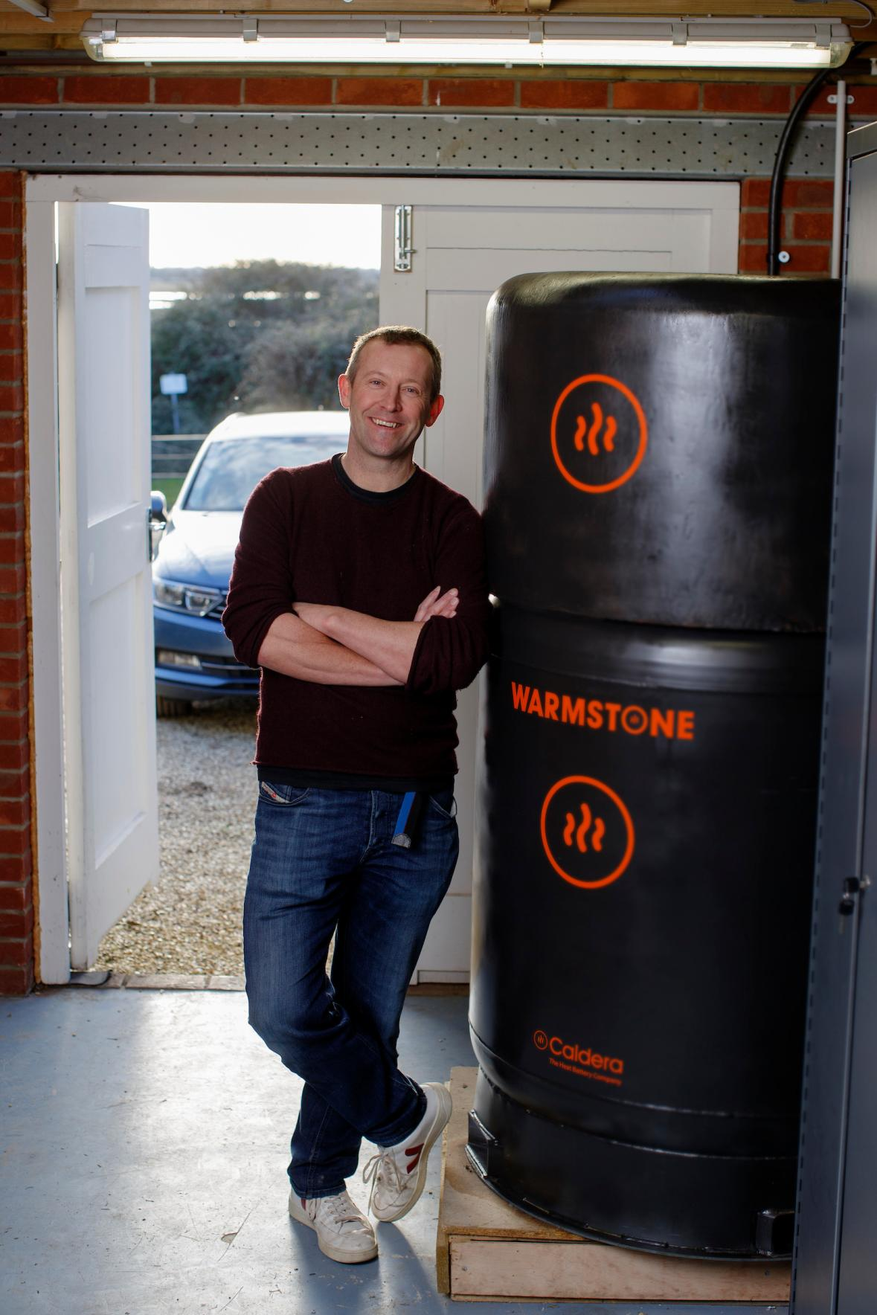
James Macnaghten says the unit would meet the heating and hot-water needs of a four-bedroom home for 24 hours in the depths of winter
LUKE MACGREGOR
Caldera is now conducting an external fundraising round that has so far raised more than £600,000 through a combination of crowdfunding, other private investors, and a £130,000 “strategic” investment from the German multinational König Metall. Caldera was founded in 2017 by the engineers James Macnaghten and Guy Winstanley. Macnaghten, 51, previously ran Isentropic, an electricity storage business that fell into administration in 2016, and also owns Scudamore’s, a Cambridge punting company.
The only Warmstone heat battery to date is installed in Macnaghten’s home but the company plans to install ten more by next winter.
Decarbonising home heating is one of the biggest challenges facing Britain as it pursues its goal of net zero emissions by 2050. There is febrile debate between advocates of electric heat pumps and hydrogen heating systems, but hydrogen is highly unlikely to be viable in about 20 per cent of properties that are not already on the gas network.
“There is no single solution to decarbonising all of the UK’s homes, but we believe heat batteries offer a cost-effective and easily adopted solution for many hard to heat homes,” Macnaghten said.
He said the heat battery reached 500C when fully “charged” and the vacuum-insulated unit should lose less than 10 per cent of its heat over 24 hours. It is designed to store up to 100 kilowatt-hours of heat, which he said would meet the heating and hot-water needs of a four-bedroom home for 24 hours in the depths of winter.

