JCB finds cheap way to run digger using hydrogen
new
Graeme Paton,
Friday May 21 2021, 5.00pm, The Times

Technology

Transport

Companies

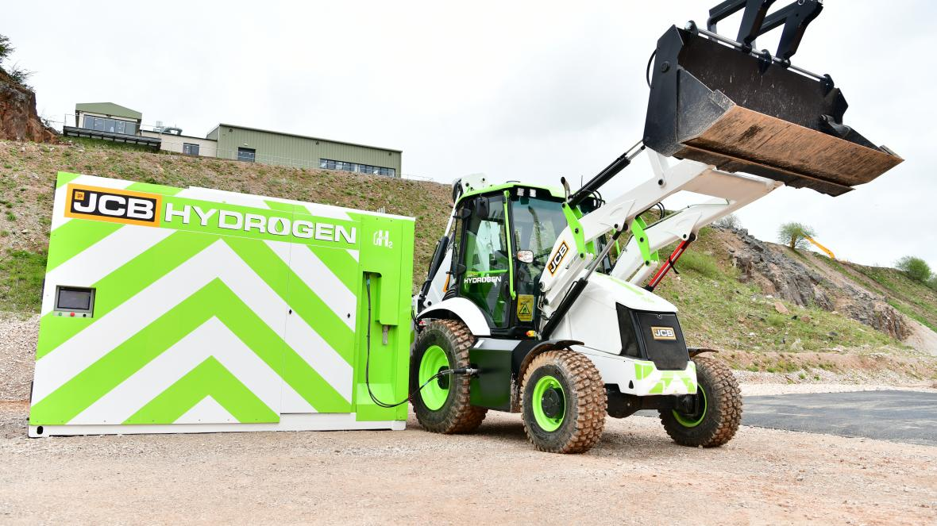
JCB says that the technology could be applied in trucks, vans, trains, buses and even large cars
JCB
Share

Save

An operational hydrogen combustion engine developed in Derbyshire could speed up the shift towards zero-emissions transport.
JCB, the construction equipment manufacturer, said that the engine would be capable of powering heavy machinery and vehicles without producing any carbon dioxide.
The company said that the technology — a modified version of its latest diesel engine — would provide green transport at about a tenth of the cost of other zero-emission solutions. This includes battery power, which can be impractical for many heavy vehicles, and hydrogen fuel cells, which are relatively expensive to develop and maintain.
The engines are principally being built for JCB’s off-road machinery but it is claimed that the technology could be applied in trucks, vans, trains, buses and even large cars. The engine, which has been in development since July at its research facility in Foston, Derbyshire, has already been installed in one of JCB’s 3CX backhoe loaders and trials are continuing.
Lord Bamford, the company’s chairman, said that the engine could go into pre-production by the end of next year.
It has the potential to accelerate the transition away from fossil fuel for hundreds of thousands of vehicles. The government has already set a target to ban the sale of petrol and diesel cars and vans by 2030 in the drive towards net-zero carbon emissions by 2050. It is expected that the shift will be achieved through battery technology, and almost 14 per cent of new cars sold since the start of this year are pure electric or hybrid models.
However, the transition will be harder to achieve in large vehicles where the size, weight and charging time of batteries can be impractical. Some buses and cars are powered using hydrogen fuel cells, in which electrical power is generated through a chemical reaction, although this can be expensive and has extensive technical challenges.
JCB is developing a working hydrogen motor. Like a conventional diesel engine, it relies on the combustion of fuel to generate power. Hydrogen gas, which has a high energy density, is carried in pressurised tanks on the vehicle and injected into the engine with compressed turbocharged air. Burning hydrogen at high temperatures in a combustion engine can cause toxic nitrogen oxides (NOx), a pollutant. To combat this the JCB engine uses a low level of hydrogen — about one part to 100 parts of air — to control the combustion temperatures. Burning hydrogen and oxygen also produces water, requiring engineers to develop systems to manage the steam released through the process.
The company said that its prototype piston engine produced no CO₂ and “practically zero” levels of NOx.
It is thought that the hydrogen engines will cost about £10,000 each; costs will be kept down by using the same production lines and many of the same components as diesel engines. By comparison a prototype hydrogen fuel cell system, which is being adapted for a 20-tonne excavator as part of another JCB trial, will cost about £100,000. Batteries needed to power such a machine would probably cost in the region of £160,000, the company said.
Bamford, a Conservative Party donor, said that the Department for Transport appeared to have a “pretty closed mind” on the benefits of hydrogen, placing more energy and money on the development of battery power.
“The use of hydrogen motors will provide the quickest way to reach the target of zero carbon dioxide emissions,” he said. “The use of fossil fuels in machinery may be phased out in the future but that shouldn’t mean that internal combustion engines don’t have an important ongoing role.”

